**“**SMART STREET LIGHTING SYSTEM**”**

**Purpose of this project** :

Due to the increase of environmental concerns, lighting control systems will play an important role in the reduction of energy consumption of the lighting without impeding comfort goals. As mentioned the energy is the single most important parameter to consider when assessing the impacts of technical systems on the environment. Energy related emissions are responsible for approximately 80% of air emissions and central to the most serious global environmental impacts and hazards, including climate change, acid deposition, smog and particulates. Lighting is often the largest electrical load in offices, but the cost of lighting energy consumption is low when compared to the personnel costs. Thus its energy saving potential is often neglected. Intelligent lighting control and energy management system is a perfect solution for energy saving, especially in public lighting management.

**Scope of this project :**

It realizes remote on/off and dimming of lights, which can save energy by 40%, save lights maintenance costs by 50%, and prolong lamp life by 25%. The system application in streetlight control for each lamp will reduce in streetlight electricity and maintenance cost, and increase availability of street light.

**Existing System:**

Industry of street lighting systems are growing rapidly and going to complex with rapid growth of industry and cities. Automation, Power consumption and Cost Effectiveness are the important considerations in the present field of electronics and electrical related technologies. To control and maintain complex street lighting system more economically, various street light control systems are developed. These systems are developed to control and reduce energy consumption of a town's public lighting system using different technologies. The existing work is done using HID lamps.

**Proposed System** :

Since the HID lamps are not cost effective and not reliable, smart street light system has overcome by replacing the HID lamps with LED.

**Hardware specification**

Arduino UNO R3

Infrared sensor

**SYSTEM ARCHITECTURE**

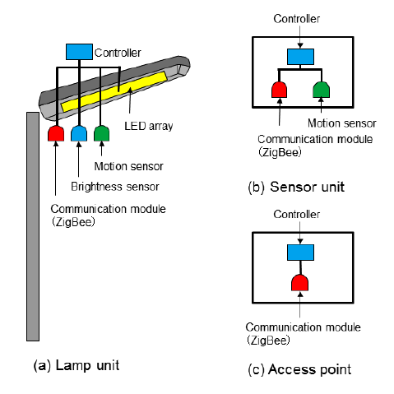

**Limitations of the system:**.

* + Model cannot work efficiently when object motion is fast.
  + Protection of sensors need to be provided.

**Future Enhancements:**

Smart streetlighitng system will be a very successful project in near future As LED lighting continues to become more affordable, cities around the world have begun investigating the benefits of switching from traditional street lighting to the far more energy-efficient technology.Alongside the energy savings, lifespan, and quality of light improvements that LEDs offer, the enhanced controllability of this technology through the adoption of intelligent networking solutions has the ability to revolutionize the way cities utilize their street lighting infrastructure in order to deliver an attractive, sustainable, and safer living space. A change that will allow achieving some important goals. Namely, reducing the city’s energy consumption thanks to energy efficient luminaires, extending the lifespan of the city lighting and controlling light pollution by enabling the regulation of the intensity of light when and where it’s needed. The new lighting installation allows us to make significant progress towards becoming a smart city, which is more sustainable and, in conclusion, a more livable city.

***REFERENCES***

* ***Instructables (***[***https://www.instructables.com/***](https://www.instructables.com/)***)***
* ***Trello (***[***https://trello.com/***](https://trello.com/)***)***
* ***Wikipedia (***[***https://en.wikipedia.org/wiki/Main_Page***](https://en.wikipedia.org/wiki/Main_Page)***)***
* ***IEEE RESEARCH PAPER(***[***http://ieeexplore.ieee.org/document/6645937/?reload=true***](http://ieeexplore.ieee.org/document/6645937/?reload=true)***)***

***TEAM MEMBERS***

1. Bommareddy Saranya-16R21A05J9
2. Karingula Krutika-16R21A05L7
3. Kondaparthi Harika-16R21A05L4
4. Gayam Haritha-16R21A05L1
5. Chikkala Sai Navyasree-16R21A05K4